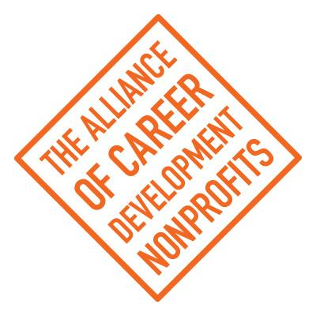
Call for Board of Directors Nominations

2021 was a period of growth for ACDN. It has included an introduction of new board members coming from rich and diverse backgrounds.In order to maintain the goals of the member organizations we seek to ensure a balance of Directors who come directly from our member agencies.

To effectively fulfill the role as an individual board member, it is not only important that you carry out these responsibilities, but also that you demonstrate qualities that are essential to a board's success, such as:

Board Member Attributes and Qualifications:
- Effective communication and leadership skills
- Proven initiative and follow through
- Support of Alliance of Career Development Nonprofit’s mission and strategic goals
- Flexibility/ability to plan for and manage change
- Diversity and team approach to leadership; consensus builder
- Previous board experience
- Technological capacity and skills
- Comfortable with role as advocate for Alliance of Career Development Nonprofits
- Strategic, visionary and critical thinker; able to think outward and forward
- Clear understanding of board role and executive director role
- Respect for others' contributions
- Creativity and innovation
- A positive attitude
- Constructive problem-solving skills
- A willingness to contribute your skills, knowledge, ideas and influence
- Financial capacity to participate in monthly board conference calls, yearly strategic planning meeting and annual national conference at own expense.

Position Description

A Director’s term shall be two (2) years, and a Director may be elected for four (4) consecutive terms. Directors are elected at the annual meeting with their terms becoming effective on January 1st of the upcoming year. Following an absence from the board of at least one year, a former director is again eligible for election to the Board as set forth above. (Section 3.4)

- Board members manage the business affairs of ACDN, including establishing policies and procedures, which govern the organization and its members.
- Board members have a fiduciary responsibility to oversee ACDN’s finances, including being actively involved in fundraising and promoting the organization.
- Board members actively participate in the governance of ACDN by thinking critically and strategically about ACDN’s activities, which includes coming prepared to meetings, asking tough discerning questions and chairing committees.
- Board members agree to participate in monthly conference calls and two in-person meetings annually at their own expense. Board members are not compensated by ACDN for travel and communication expenses.

Nomination Procedure:
- Board Membership Application forms and current resumes from potential board members are due to Gineyda Diaz, Board President, at gdiaz@acdnonline.org.
- ACDN Board of Directors will review all submissions and arrange telephone meetings with viable candidates. Interested candidates are encouraged to talk with a member of ACDN Board before submitting an application.
- The Board will present a slate of directors to the full membership at our Annual Meeting on October 1, 2022 in Washington, DC. All potential board members are encouraged to attend.

STATEMENT OF INTEREST / APPLICATION FOR CONSIDERATION
FOR Board appointment to Alliance of Career Development Nonprofits (ACDN)

Name:

Address:

Phone Number: (w): (h):

Email Address: Fax Number:

Are you a Board Member or a staff person of a member organization of Alliance of Career Development Nonprofits (ACDN)? If so, which agency, what is your position and how long have you been affiliated with the organization?

If you are not a Board Member of a staff person of a member organization of Alliance of Career Development Nonprofits (ACDN), please describe your relationship with ACDN or interest in ACDN.

Please describe your specific areas of interests and the skills that you believe you will bring to the Alliance of Career Development Nonprofits (ACDN) Board of Directors.

Have you served on the Board of Directors of any other nonprofit organizations? If so, please describe that experience.

If elected to the Board of Directors of Alliance of Career Development Nonprofits (ACDN), what areas are you interested in assisting with:

Fundraising (i.e., grant writing, corporate and individual solicitation)
Membership Management (i.e., new member applications, member services)
Annual Conference
Finance Committee
Technology Committee
Board Development and Strategic Planning
Social Entrepreneurship
Advocacy
PR/Marketing/Communications
Corporate Partnerships
Other (please explain)________________________________________________

Please attach a current resume.
Thank you for your interest in serving on the Board of Directors
of Alliance of Career Development Nonprofits (ACDN).

